-- Combined basic logic gates

library ieee;

use ieee.std_logic_1164.all;

entity ayush_basicgates is

port(a,b: in std_logic;

c,d,e,f,g,h,i: out std_logic);

end ayush_basicgates;

architecture dataflow of ayush_basicgates is

begin

c<= a and b;

d<= a or b;

e<= not b;

f<= a xor b;

g<= a nand b;

h<= not(a xor b);

i<= a nor b;

end dataflow;

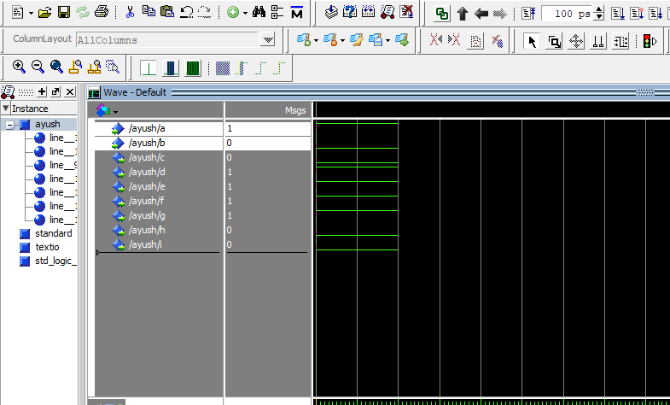

-- half adder

library ieee;

use ieee.std_logic_1164.all;

entity ayush_halfadder is

port(a: in std_logic; b: in std_logic;

s: out std_logic,cy: out std_logic);

end ayush_halfadder;

architecture dataflow of ayush_halfadder is

begin

s<= a xor b;

c<= a and b;

end dataflow;

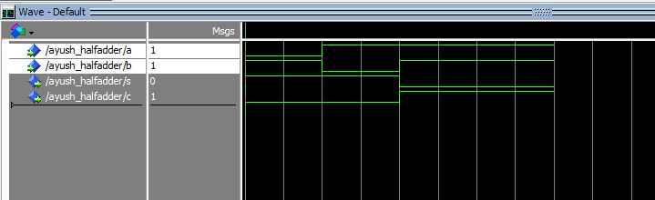

-- Full adder

library ieee;

use ieee.std_logic_1164.all;

entity ayush_fulladder is

port(a,b,c: in std_logic;

s,cy: out std_logic);

end ayush_fulladder;

architecture dataflow of ayush_fulladder is

begin

s<= (a xor b) xor c;

cy<= (a and b) or (b and c) or (c and a);

end dataflow;

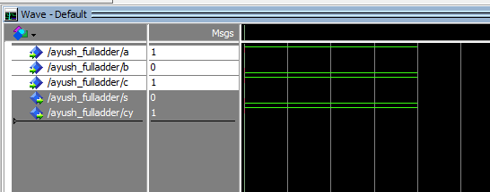

-- Binary Adder Subtractor

LIBRARY ieee;

USE ieee.STD_LOGIC_1164.ALL;

USE ieee.STD_LOGIC_UNSIGNED.ALL;

ENTITY ayush_bas IS

PORT(

A:IN STD_LOGIC_VECTOR(3 DOWNTO 0);

B: IN STD_LOGIC_VECTOR(3 DOWNTO 0);

MODE: IN STD_LOGIC;

SUM: OUT STD_LOGIC_VECTOR(3 DOWNTO 0);

CARRY: OUT STD_LOGIC

);

END ayush_bas;

ARCHITECTURE BEHAVIORAL OF ayush_bas IS

SIGNAL B_twos_COMPLIMENT : STD_LOGIC_VECTOR(3 DOWNTO 0);

BEGIN

B_twos_COMPLIMENT <= (B XOR (MODE & MODE & MODE & MODE ))+MODE;

PROCESS(A,B_twos_COMPLIMENT,MODE)

VARIABLE TEMP: STD_LOGIC_VECTOR(4 DOWNTO 0);

BEGIN

TEMP :=('0' & A)+('0' & B_twos_COMPLIMENT);

SUM<=TEMP(3 DOWNTO 0);

CARRY<= TEMP(4);

END PROCESS;

END BEHAVIORAL;

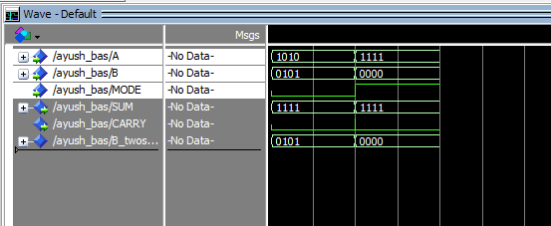

-- Overflow

library IEEE;

use IEEE.STD_LOGIC_1164.ALL;

use IEEE.STD_LOGIC_ARITH.ALL;

use IEEE.STD_LOGIC_UNSIGNED.ALL;

entity ayush_overflow is

Port (a : in std_logic_vector (3 downto 0);

b : in std_logic_vector (3 downto 0);

overflow : out STD_LOGIC);

end entity ayush_overflow;

architecture Behavioral of ayush_overflow is

begin

process(a,b)

variable sum: std_logic_vector(4 downto 0);

begin

sum := ('0' & a)+('0' & b);

if sum(sum'high)='1'

then overflow <='1';

else

overflow <='0';

end if;

end process;

end architecture Behavioral;

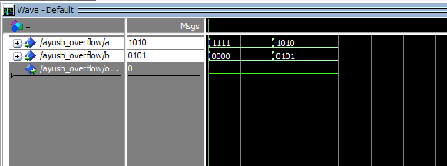

-- ALU

library ieee;

use ieee.std_logic_1164.all;

use ieee.numeric_std.all;

entity ayush_alu is

port (

A,B :in std_logic_vector (3 downto 0);

op :in std_logic_vector (2 downto 0);

Result :out std_logic_vector (3 downto 0);

Zero : out std_logic

);

end ayush_alu;

architecture Behavioral of ayush_alu is

begin

process (A, B, Op)

variable temp_result : std_logic_vector (3 downto 0);

begin

case Op is

when "000" =>

temp_result :=std_logic_vector (unsigned (A) + unsigned(B));

when "001" =>

temp_result :=std_logic_vector (unsigned (A) - unsigned(B));

when "010" =>

temp_result := A and B;

when "011" =>

temp_result := A or B;

when "100" =>

temp_result := A xor B;

when others =>

temp_result:= (others => '0');

end case;

Result <= temp_result;

if temp_result ="0000" then

Zero <='1';

else

Zero <='0';

end if;

end process;

end Behavioral;

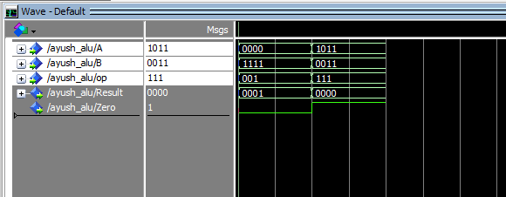

-- Control unit

library ieee;

use ieee.std_logic_1164.all;

entity ayush_cu is

port(

input1 : in std_logic;

input2 : in std_logic;

ctrl : in std_logic;

output1 : out std_logic;

output2 : out std_logic

);

end ayush_cu;

architecture behavioral of ayush_cu is

begin

process (input1, input2,ctrl)

begin

case ctrl is

when '0' =>

if input1 = '1' then

output1 <= '1';

else

output1 <= '0';

end if;

if input2 ='1' then

output2 <= '1';

else

output2 <= '0';

end if;

when '1' =>

output1 <= input1 and input2;

output2 <= input1 or input2;

when others =>

output1 <= '0';

output2 <= '0';

end case;

end process;

end behavioral;

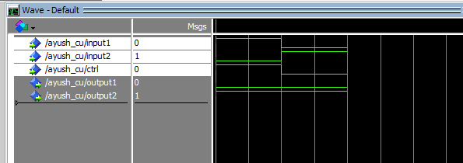

-- Mapping

library ieee;

use ieee.std_logic_1164.all;

entity ayush_mapping is

port(

clk : in std_logic;

reset : in std_logic;

enable : in std_logic;

data_in : in std_logic_vector(7 downto 0);

data_out : out std_logic_vector(7 downto 0)

);

end entity ayush_mapping;

architecture behavioral of ayush_mapping is

signal reg_data: std_logic_vector(7 downto 0);

begin

process (clk, reset)

begin

if reset ='1' then

reg_data <= (others => '0');

elsif rising_edge(clk) then

if enable = '1' then

reg_data <= data_in ;

end if;

end if;

end process;

data_out <= reg_data;

end architecture behavioral;

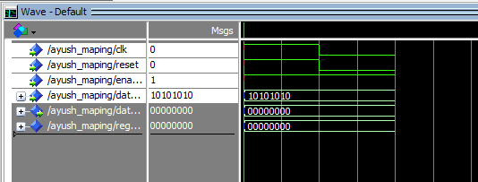

-- Parity generator

library ieee;

use ieee.std_logic_1164.all;

use ieee.std_logic_arith.all;

use ieee.std_logic_unsigned.all;

entity ayush_pg is

port(

data_in : in std_logic_vector(7 downto 0);

parity_type : in std_logic;

parity_bit : out std_logic

);

end ayush_pg;

architecture behavioral of ayush_pg is

begin

process (data_in, parity_type)

variable temp : std_logic;

begin

temp:= '0';

for i in data_in'range loop

temp:= temp xor data_in(i);

end loop;

if parity_type = '1' then

parity_bit <= not temp;

else

parity_bit <= temp;

end if;

end process;

end behavioral;

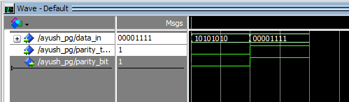

-- Parity checker

library ieee;

use ieee.std_logic_1164.all;

use ieee.std_logic_arith.all;

use ieee.std_logic_unsigned.all;

entity ayush_pc is

port(

data_in : in std_logic_vector(7 downto 0);

parity_type : in std_logic;

received_parity : in std_logic;

error_flag : out std_logic

);

end ayush_pc;

architecture behavioral of ayush_pc is

begin

process (data_in,received_parity, parity_type)

variable temp_check : std_logic;

begin

temp_check:= '0';

for i in data_in'range loop

temp_check:= temp_check xor data_in(i);

end loop;

temp_check := temp_check xor received_parity;

if (parity_type = '1' and temp_check = '0') or (parity_type = '0' and temp_check = '1') then

error_flag <= '1';

else

error_flag <= '0';

end if;

end process;

end behavioral;

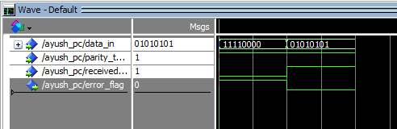

-- Encoder

library ieee;

use ieee.std_logic_1164.all;

entity ayush_en is

port (

p: in std_logic_vector (3 downto 0);

y: out std_logic_vector(1 downto 0)

);

end ayush_en;

architecture behavioral of ayush_en is

begin

process(p)

begin

case p is

when "0001" => y <= "00";

when "0010" => y <= "01";

when "0100" => y <= "10";

when "1000" => y <= "11";

when others => y <= "UU";

end case;

end process;

end behavioral;

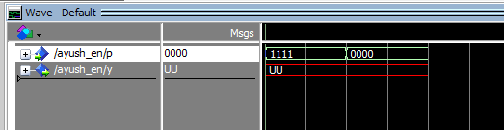

-- Decoder

library ieee;

use ieee.std_logic_1164.all;

entity ayush_de is

port (

A: in std_logic_vector (1 downto 0);

D: out std_logic_vector(3 downto 0)

);

end ayush_de;

architecture behavioral of ayush_de is

begin

with A select

D <= "0001" when "00",

"0010" when "01",

"0100" when "10",

"1000" when "11",

"0000" when others;

end behavioral;

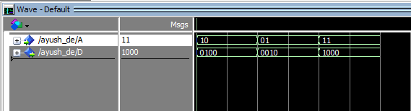

- Multiplexer

library ieee;

use ieee.std_logic_1164.all;

entity ayush_mux is

port(a,b:in std_logic;

s:in std_logic;

y:out std_logic);

end ayush_mux;

architecture beh of ayush_mux is

begin

process (a,b,s)

begin

case s is

when '0' => y <= a;

when '1' => y <= b;

when others => y <= 'U';

end case;

end process;

end behavioral;

